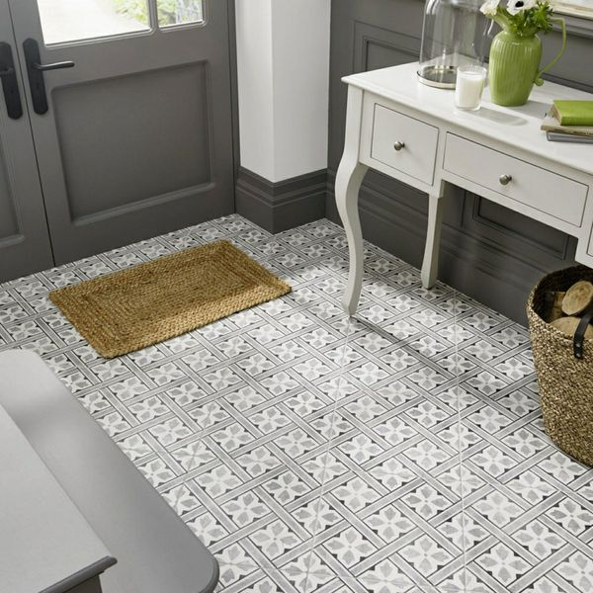**Mr Jones Charcoal Tiles:**

**Product Description**

Create a vintage-styled statement floor in any room throughout your home with these charming Mr Jones Charcoal Tiles. Made from ceramic, they're easy to work with and easy to clean, and they have a subtle matt finish that fits the era from which they are inspired.

**What's special about these tiles?**

> Vintage-styled geometric pattern   
> Easy to clean   
> Made from durable ceramic  
> Perfect for creating a period statement floor

## **Product Info**

* Product ID: 43419
* Tiles Per SQM: 4.9382716049383
* Sale by: Per SQM
* Size: 450x450x9mm
* Weight: 3.80 KG
* Material Type: Ceramic
* Finish: Matt
* Colour: Grey
* Suitability: Floors, Walls
* Grade: 4
* Rectified Edge: No
* Underfloor Heating: Yes
* Anti Slip Grade: R10 / 10-19 Degrees
* Thickness (mm): 9